Compte Rendu Hesters Théophile

Ex 1.1.100
<!DOCTYPE <!DOCTYPE html>
<html>

<head>
<meta charset="utf-8" />
<meta http-equiv="X-UA-Compatible" content="IE=edge">
<title>Hesters Théophile</title>
<script>
function reponse(form) {
if ((form.choix1.checked == true) && (form.check1.checked == true) && (form.check2.checked == false) && (
form.formulaire.selected == 2)) alert("C'est la bonne r\351ponse !");
elsealert("D\351sol\351, continuez \340 chercher...");
}
</script>

</head>

<body>
<!--RADIO-->
Un angle droit doit faire <form name="formulaire"><input type="radio" name="45" value="1">45°<br><input type="radio"
name="bon1" value="2">90°<br>
<!--CASES-->
Un triangle isocèle possède : </br>
<form name="formulaire"><input type="checkbox" name="check1" value="1">2 Côtés égaux<br><input type="checkbox"
name="check2" value="2">3 Côtés égaux<br>
<!--Déroulant-->
Un triangle équilatéral possède : <form name="formulaire"><select name="list">
<option value="1">2 Côtés égaux<option value="2">3 Côtés égaux</br>
</select>
<input type="button" name="but" value="Corriger" onclick="reponse(form)"></form>

</html>
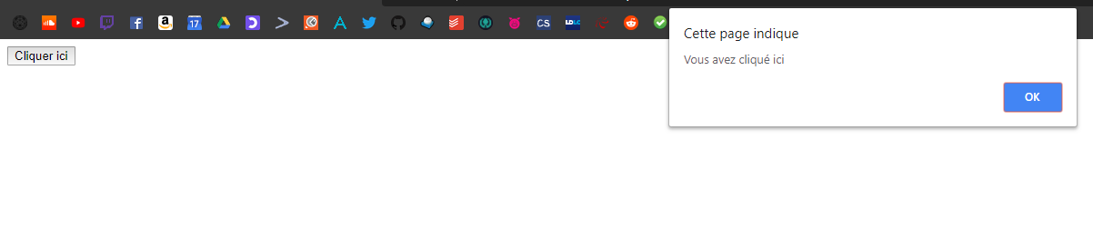
Ex 1.1.101
<!DOCTYPE html>
<html>

<head>
<title>onfocus</title>
</head>

<body>
<form name="form"><input name="t1" type="text" onfocus="document.form.t1.value='Entrer votre nom ici !'"><br><input
name="t2" type="text" onfocus="document.form.t2.value='Entrer votre pr&eacute;nom ici !'"></form>
</body>

</html>
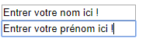
Ex 1.1.102
<!DOCTYPE html>
<html>

<head>
<title>onload et onunload</title>
</head>

<body onload="alert('Bienvenue !')" onunload="alert('A bient\364t...')"><a href="onfocus.htm">Page suivante</a></body>

</html>
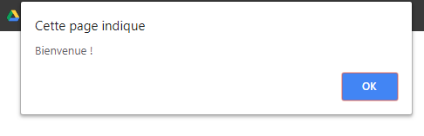
Ex 1.1.103
<!DOCTYPE html>
<html>

<head>
<title>rollover</title>
</head>

<body>
<img name="image" src="./Assets/voiture1.png" onmouseover="document.image.src='./Assets/voiture2.png';" onmouseout="document.image.src='./Assets/voiture1.png';"></body>

</html>



Ex 1.1.105
<!DOCTYPE html>
<html>

<head>
<title>rollover CSS</title>
<style>
a.image {
display: block;
width: 1280px;
height: 720px;
background-image: url(Assets/bato.jpg);
background-repeat: no-repeat;
}

a.image:hover {
background-image: url(Assets/trump.jpg);
}
</style>
</head>

<body><a class="image" src="./Assets/bato.jpg"></a></body>

</html>
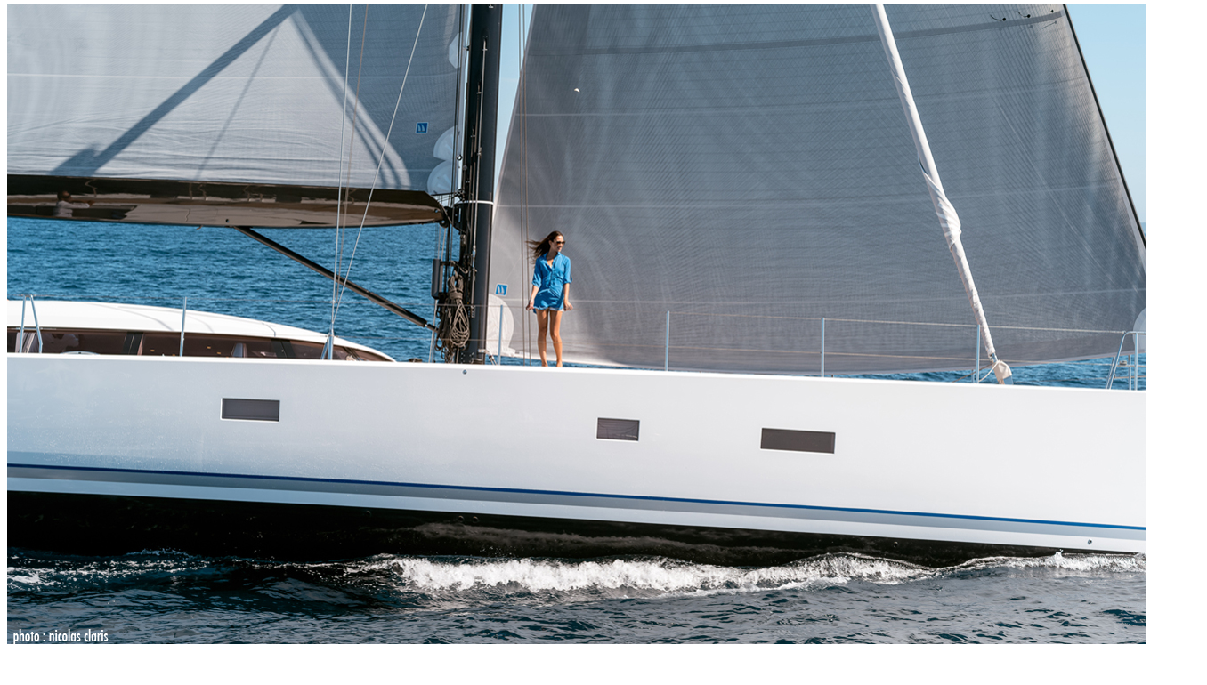
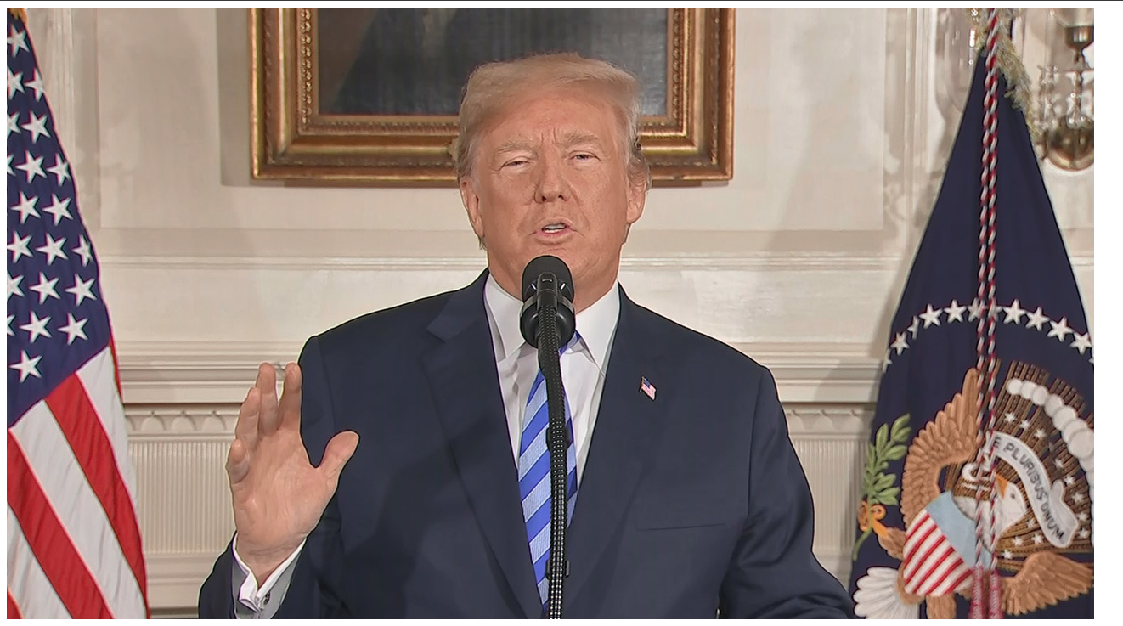

Ex 1.1.106

<!DOCTYPE html>
<html>

<head>
<title>onsubmit</title>
<script type="text/javascript" language="javascript1.2">
function verif() {
a = document.formulaire.texte1.value;
b = document.formulaire.texte2.value;
c = document.formulaire.texte3.value;
if (a == "" || b == "" || c == "") {
alert("Au moins un champ est vide !");
return false;
}
return true;
}
</script>
</head>

<body>
<form name="formulaire" onsubmit="return verif();"><input name="texte1" size="26"><br><input name="texte2" size="26"><br><input
name="texte3" size="26"><br><input type="submit"></form>
</body>

</html>
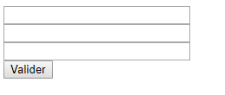

Ex 1.2
<!DOCTYPE <!DOCTYPE html>
<html>
<head>
<meta charset="utf-8" />
<meta http-equiv="X-UA-Compatible" content="IE=edge">
<title>Hesters</title>
<meta name="viewport" content="width=device-width, initial-scale=1">
<link rel="stylesheet" type="text/css" media="screen" href="main.css" />
<script src="main.js"></script>
</head>
<body>
<form name="form"><input name="t1" type="text" onfocus="document.form.t1.value='Entrez votre mail ici !'"><br></form>
</body>
</body>
</html>


Ex 1.3
<!DOCTYPE <!DOCTYPE html>
<html>

<head>
<meta charset="utf-8" />
<meta http-equiv="X-UA-Compatible" content="IE=edge">
<title>On reset</title>
<script type="text/javascript" language="javascript1.2">
function alerte() {
alert("Ceci est un message d'alerte !");
}
</script>

</head>

<body>
<form name="form"><input name="t1" type="text" onfocus="document.form.t1.value='Entrez votre mail ici !'"><br></form>
<form><input type="button" value="Reset" onclick="alert('Ceci effacera les données')" nclick='window.location.reload(false)';></form>
</body>

</html>
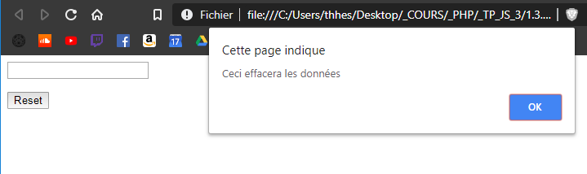

Ex 2.1.109
<!DOCTYPE <!DOCTYPE html>
<html>

<head>
<meta charset="utf-8" />
<meta http-equiv="X-UA-Compatible" content="IE=edge">
<title>Hesters Téhophile</title>
<script type="text/javascript" language="javascript1.2">
function controler(formulaire) {
var test = document.formulaire.input.value;
alert("Vous avez saisi : " + test);
}
</script>
</head>

<body>

<form name="formulaire"><input type="text" name="input" value=""><br><input type="button" name="bouton" value="Contr&ocirc;ler"
onclick="controler(formulaire)"></form>
</body>

</html>
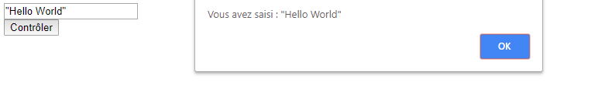

Ex 2.1.110
<!DOCTYPE <!DOCTYPE html>
<html>

<head>
<meta charset="utf-8" />
<meta http-equiv="X-UA-Compatible" content="IE=edge">
<title>Hesters Théophile</title>
<script type="text/javascript" language="javascript1.2">
function copier() {
var testin = document.formulaire.input.value;
document.formulaire.output.value = testin;
}
</script>

</head>

<body>
<form name="formulaire">Texte d'entr&eacute;&nbsp;:&nbsp;<input type="text" name="input" value=""><br><input type="button"
name="bouton" value="Afficher" onclick="copier()"><br>Texte de sortie&nbsp;:&nbsp;<input type="text" name="output"
value=""><br>
</form>
</body>

</html>
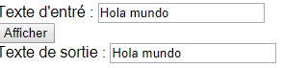

Ex 2.1.111
<!DOCTYPE html>
<html>

<head>
<title>focus</title>
</head>

<body onload="document.formulaire.entree.focus();">
<form name="formulaire"><input type="text" name="entree" size="25" value=""><input type="text" name="entree2" size="25"
value=""></form>
</body>

</html>
Ex 2.1.112
<!DOCTYPE html>
<html>

<head>
<title>nombre</title>
<script type="text/javascript" language="javascript1.2">
function verifn() {
var n = document.formulaire.nombre.value;
if (isNaN(n) || (n == 0)) alert("Entrer un nombre SVP !");
elsealert("Entr\351e valide...");
}
</script>
</head>

<body>
<form name="formulaire">Code postal&nbsp;:&nbsp;<input type="text" name="nombre" size="5" maxlength="5"><br><input
type="button" name="bouton" value="Tester" onclick="verifn()"><br></form>
</body>

</html>
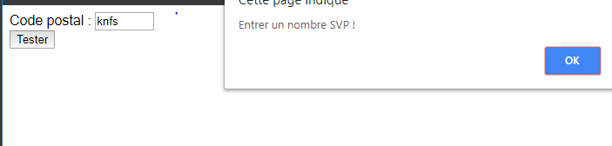
Ex 2.1.114
<!DOCTYPE html>
<html>

<head>
<title>boutons radio</title>
<script type="text/javascript" language="javascript1.2">
function choixsexe(form) {
if (form.choix[0].checked) alert("Proposition " + form.choix[0].value);
if (form.choix[1].checked) alert("Proposition " + form.choix[1].value);
}
</script>
</head>

<body>Entrez votre choix <form name="formulaire"><input type="radio" name="choix" value="1">Sexe masculin<br><input
type="radio" name="choix" value="2">Sexe f&eacute;minin<br><input type="button" name="but" value="Quel est votre choix ?"
onclick="choixsexe(document.formulaire)"></form>
</body>

</html>
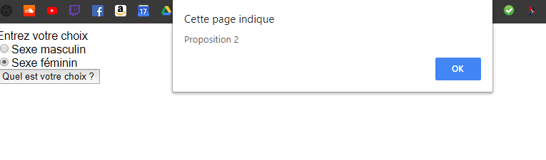
Ex 2.1.117
<!DOCTYPE html>
<html>

<head>
<title>cases &agrave; cocher</title>
<script type="text/javascript" language="javascript1.2">
function reponse(form) {
if ((form.check1.checked == true) && (form.check2.checked == true) && (form.check3.checked == false) && (
form.check4.checked == true)) alert("C'est la bonne r\351ponse !");
elsealert("D\351sol\351, continuez \340 chercher...");
}
</script>
</head>

<body>S&eacute;lectionnez les balises HTML : <form name="formulaire"><input type="checkbox" name="check1" value="1">&lt;h1&gt;
... &lt;/h1&gt;<br><input type="checkbox" name="check2" value="2">&lt;a&gt; ... &lt;/a&gt;<br><input type="checkbox"
name="check3" value="3">&lt;op&gt; ... &lt;/op&gt;<br><input type="checkbox" name="check4" value="4">&lt;b&gt;
... &lt;/b&gt;<br><input type="button" name="but" value="Corriger" onclick="reponse(document.formulaire)"></form>
</body>

</html>
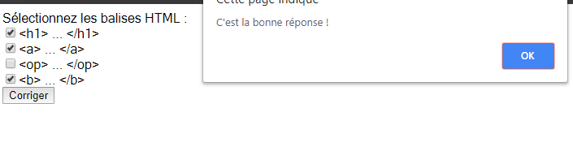

Ex 2.1.118
<!DOCTYPE html>
<html>

<head>
<title>liste d&eacute;roulante</title>
<script type="text/javascript" language="javascript1.2">
function liste(form) {
alert("Le navigateur " + (form.list.selectedIndex + 1));
}
</script>
</head>

<body>Quel navigateur utilisez-vous ?<form name="formulaire"><select name="list">
<option value="1">Internet Explorer<option value="2">Firefox<option value="3">Autre
</select><input type="button" name="b" value="R&eacute;ponse" onclick="liste(document.formulaire)"></form>
</body>

</html>
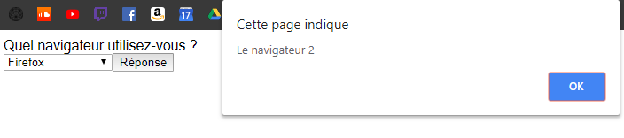

Ex 2.1.120
<!DOCTYPE html>
<html>

<head>
<title>un seul clic</title>
<script type="text/javascript" language="javascript1.2">
var nombreclic = 0;

function compteclic(form) {
nombreclic++;
if (nombreclic > 1) alert(
"Vous avez d\351j\340 cliqu\351 ce bouton.\nLe formulaire est en cours de traitement...");
}
</script>
</head>

<body>
<form name="formulaire"><input type="button" value="Cliquez-moi !" onclick="compteclic(document.formulaire)"></form>
</body>

</html>
